Summary

Scientists/hydrologists/people completely underestimate the problem of wind-induced undercatch and the effect it has on the catch of rain gauges. There is a false assumption that a “can-type” simple bucket measuring device will be adequate. This is completely untrue!

- Vitally important to measure precipitation events accurately in the UK:
  - Hazards mitigation e.g. Real time flood forecasting
    - Increasing magnitude of the extreme events will result in higher risk.
    - Flood risk = probability of occurrence x consequences.
  - Agriculture
  - Water resources (e.g. managing drought in south east)
  - Climate studies
  - Forecasting

- Inaccuracies in ground-based point precipitation measurements are propagated with the use of statistical interpolation techniques (e.g. Kriging / Thiessen). This underlines importance of accuracy.

- Aerodynamic shape of the gauge is highly significant. A more aerodynamic rain gauge records more catch – very high confidence. I.e. SBS and ARG 100 better than Casella (Figure 3)

- New instrumentation (e.g. WXT 520 impact disdrometer) can play a vital role in the development of accurate measurements. The weather transmitter appears to collect more rain in higher wind speeds than TBRs (Figure 2), but other aspects may still benefit from technical or programming development/refinement e.g. rainfall collection at low intensities is questioned. They are still affected by the wind (because of the reason outlined below) but if placed in a pit they will be able to produced accurate readings.

Reason: The aerodynamic blockage due to the physical presence of the gauge causes acceleration of wind flow over the gauge orifice. The trajectories of precipitation particles become distorted, some of the lighter particles are borne away before reaching the gauge and are lost from measurement. Therefore any device which causes a physical distortion of the wind flow due to its presence is subject to wind-induced undercatch.
NB. There are studies still being published in the literature which do not convey an appropriate level of understanding of this issue, and do not employ the use of correction methods.

- Existing evaluations of implications of wind-induced loss from UK literature (SPARSE!):

- In some of the UK’s wetter catchments (Eden), the estimated percentage undercatch by standard rain gauges is approximately equal to the annual average evaporative loss (Hannaford and Marsh, 2008).
- Rodda and Smith (1986) showed that volumes of rain are systematically underestimated at sites across the UK by between 5 and 20%, with underestimates being more serious at sites in wetter parts of the country (Eden!).

- Correction procedures for wind-induced undercatch

- The most accurate methods of correction are applied at the highest temporal scale, with high resolution input variables (wind speed at gauge height, rainfall intensity, drop size distribution).
- Bias corrected climatologies exist for northern latitudes e.g. Siberia, China, Canada, Greenland, Mongolia. Each country has a unique national standard gauge which affects the wind-induced undercatch differently. Historic meteorological monitoring networks collect data at the daily resolution, therefore developing proxy readings for the necessary input variables is a difficult, time consuming and expensive project.
- The UK has no similar bias corrected climatology. This will hopefully change as the need for more accurate estimation of the input to the UK’s water resources becomes more pressing (due to drought in South East). Many studies (eg Burt and Ferranti, 2012, Mayes, 1996) do not apply corrections to the measured data.
NB. There is a very important issue of “scaling” with correction procedures, great care needs to be taken here otherwise overestimation can become a problem.

The problem is outlined at the national and historic scale, what can be done at the local scale which may help to develop a high resolution correction methodology? Newton Rigg (and Gais Gill…?):

- Solution to the problem, initially to be solved at the local scale (Newton Rigg to begin with):

- Placing both a weather transmitter and a TBR in a WMO reference pit with their rims flush with ground-level negates the effect of wind on both instruments. Therefore it is possible to measure the “true” precipitation.

- The “true” values of drop size distribution, rainfall intensity and wind speed at gauge orifice can therefore be attained by the weather transmitter in the pit.

- Having a TBR and a weather transmitter situated outside the pit but in the same (similar) location will provide a typical value of “measured” precipitation from instruments sitting on the ground.

- From the “true” readings taken from the instruments in the pit, and the “measured” readings take from outside the pit, a local-scale correction model can be developed.

- Another interesting experiment would be to place both a Casella and a SBS/ARG 100 in the pit because if they collect the same amount of precipitation when they are in the pit then it can be demonstrated once and for all that the aerodynamic shape is better.

- Below (Figure 1) is the enclosure at Newton Rigg, to install a pit gauge it would need to be extended.

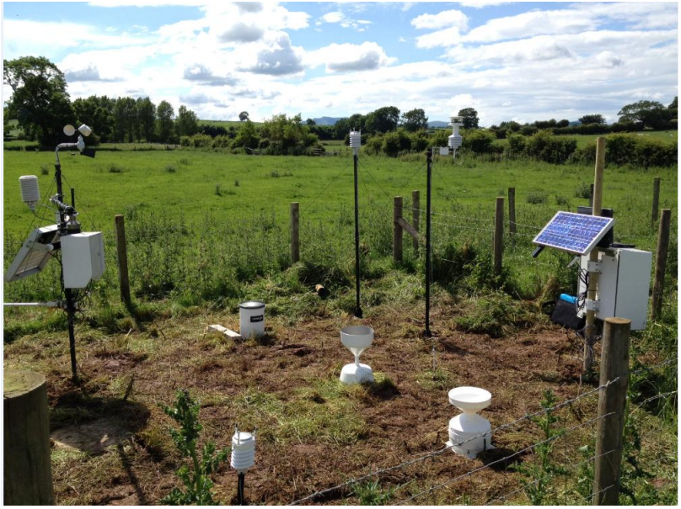

Figure 1: The equipment installed at Newton Rigg on July 5th 2012

Thus, there is great potential to use the WXT 520 to measure wind speed, drop size distribution and rainfall intensity. It would therefore be able to correct itself in real time. This issue needs to be brought to the attention of hydrologists and practitioners. There is a new market opportunity for this kit.

Notes:
- A pit gauge is the ultimate basis of accurate precipitation measurements where wind-induced undercatch is concerned, this should be the reference. Ensure that it is designed to WMO regulations.
- From the literature it is known that the relationship between wind speed and gauge catch is not linear. Three variables are needed:
  - Wind speed at gauge orifice
  - Rainfall intensity
  - Drop size distribution.
- More investigation into the performance of the WXT 520 needs to be done to see how well it measures 2 and 3. But, there is a recent paper out this year that is interesting and will help greatly (Tanvar Islam, 2012).
- The Michelson (2004) paper would be a good starting point for the correction procedure, maybe he could be contacted.
- NB. WXT 520 is the new model of the WXT 510, but they are essentially the same device.

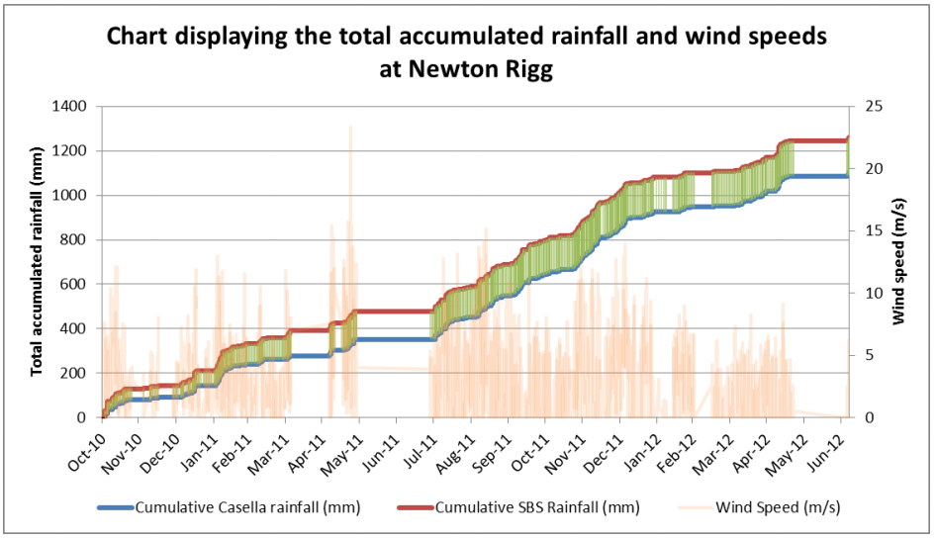

Figure 2: Total accumulated rainfall collected by each tipping bucket rain gauge at Newton Rigg.

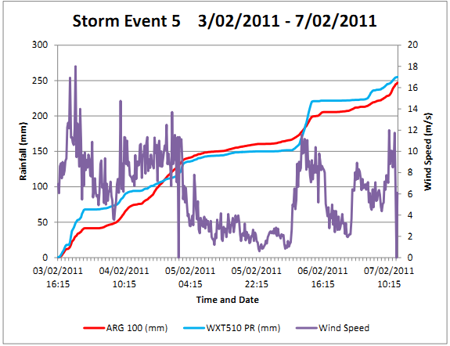
Figure 3: Storm at Gais Gill at the event scale

A: WXT 510 weather transmitter is not recording rainfall whereas the ARG 100 TBR is. Wind speeds are low (less than 4 m/s) and rainfall intensity is also low.
B: WXT 510 weather transmitter capturing more rainfall than the ARG 100 during a higher intensity portion of the storm, occurring in high wind speeds (over 8m/s).

